**A**

**PROJECT REPORT ON**

# Online Blog Management System

SUBMITTED IN PARTIAL FULFILLMENT OF

**DIPLOMA IN ADVANCED COMPUTING (PG-DAC)**



**BY**

Komal Ramdas More Kompala Mahesh Chandra Suprabha Kaduba Ragade

Veera Sai Ramesh Babu

**UNDER THE GUIDENCE OF**

**Mrs. Pooja Jaiswal**

**AT**

**SUNBEAM INSTITUTE OF INFORMATION TECHNOLOGY, PUNE**

**SUNBEAM INSTITUTE OF INFORMATION TECHNOLOGY, PUNE.**



## CERTIFICATE

This is to certify that the project

# Online Blog Management System

Has been submitted by

Komal Ramdas More

Kompala Mahesh Chandra Suprabha Kaduba Ragade

Veera Sai Ramesh Babu

In partial fulfillment of the requirement for the Course of **PG Diploma in Advanced Computing (PG-DAC AUG-2024)** as prescribed by The **CDAC** ACTS, PUNE.

Place: Pune Date: 11-FEB-2025

**Mrs. Pooja Jaiswal Mr. Yogesh Kolhe Project Guide Alumni Mentor**

## ACKNOWLEDGEMENT

We would like to take this opportunity to express our sincere gratitude to **Mr. Nitin Kudal(CEO)** and **Mr. Yogesh Kolhe(Course Coordinator)** for their invaluable guidance and support throughout this project. Their insights, encouragement, and constructive feedback at every stage have played a crucial role in shaping our work.

A special thanks to the entire faculty and staff of **Sunbeam Institute of Information Technology, Pune**, whose support and encouragement created a great learning environment for us.

This project would not have been possible without the help, patience, and motivation of everyone involved. We truly appreciate all the time and effort that went into making this a success.

Komal Ramdas More

Kompala Mahesh Chandra Suprabha Suprabha Kaduba Ragade

Veera Sai Ramesh Babu

**PG-DAC AUG2025**

**SIIT Pune**

## ABSTRACT

The Online Blog Management System is a full-stack web application built with JavaScript, React.js, Material UI, Spring Boot, MySQL, AWS, and Spring Security. It provides a secure platform for creating, managing, and interacting with blog posts, catering to admins, authors, and readers. Features include JWT-based authentication, role-based access control, post creation/editing, liking, commenting, and an admin dashboard for user and content management. The frontend, developed with React.js and Material UI, offers a responsive and visually appealing interface, while the backend, powered by Spring Boot and MySQL, ensures efficient data management. Deployed on AWS using EC2 and S3, the application is scalable and reliable. This project demonstrates my ability to build secure, scalable, and interactive web applications.

**INDEX**

|  |  |  |
| --- | --- | --- |
| **1.** | **INTRODUCTION** | 1 |
|  | 1.1 Introduction | 2 |
| **2.** | **PRODUCT OVERVIEW AND SUMMARY** |  |
|  | 2.1 Purpose | 7 |
|  | 2.2 Overview | 7 |
|  | 2.3 User Classes and Characteristics | 8 |
|  | 2.4 Design and Implementation Constraints | 9 |
| **3.** | **REQUIREMENTS** |  |
|  | 3.1 Functional Requirements | 11 |
|  | 3.1.1 Use case for Administrator. | 12 |
|  | 3.1.2 Use case for Customer. | 13 |
|  | 3.2 Non - Functional Requirements | 15 |
|  | 3.2.1 Usability Requirement |  |
|  | 3.2.2 Performance Requirement |  |
|  | 3.2.3 Reliability Requirement |  |
|  | 3.2.4 Portability Requirement |  |
|  | 3.2.5 Security Techniques |  |
| **4.** | **PROJECT DESIGN** | 16 |
|  | 4.1 Data Model | 16 |
|  | 4.1.1 Database Design |  |
|  | 4.2 Process Model | 19 |
|  | 4.2.1 Functional Decomposition Diagram |  |
|  | 4.2.2 Data Flow Diagram (DFD) |  |
| **5.** | **PROJECT RELATED STATISTICS** | 20 |
| **6** | **CONCLUSION** |  |
| **7** | **REFERENCE** | 22 |

**LIST OF TABLES**

|  |  |  |
| --- | --- | --- |
| **Section** | **Table Title** | **Page** |
| 2.3 | User class and characteristic | 12 |
| 4.1.1 | User Database Design | 14 |
| 4.1.1 | Booking Database Design | 14 |
| 4.1.1 | Feedback Database Design | 14 |
| 4.1.1 | Payment Database Design | 15 |
| 4.1.1 | Service_Provider Database Design | 16 |
| 4.1.1 | Services Database Design | 16 |
| 4.1.1 | Address Database Design | 16 |

**LIST OF FIGURES**

|  |  |  |
| --- | --- | --- |
| **Section** | **Figure Title** | **Page** |
| 3.1.1 | Admin Flow | 7 |
| 3.1.2 | Customer Flow | 8 |
| 3.1.3 | Service Provider Flow | 9 |
| 4.2.1 | ER Diagram | 10 |
| 4.2.2 | Data Flow Diagram | 11 |
| 3.1.1 | Admin Flow | 7 |
| 3.1.2 | Customer Flow | 8 |
| 3.1.3 | Service Provider Flow | 9 |

1. **INTRODUCTION**

The Online Blog Management System is a full-stack web application built with JavaScript, React.js, Material UI, Spring Boot, MySQL, AWS, and Spring Security. It provides a secure platform for creating, managing, and interacting with blog posts, catering to admins, authors, and readers. Features include JWT-based authentication, role-based access control, post creation/editing, liking, commenting, and an admin dashboard for user and content management. The frontend, developed with React.js and Material UI, offers a responsive and visually appealing interface, while the backend, powered by Spring Boot and MySQL, ensures efficient data management

**2.Scope Overview and Summary**

**2.1 Purpose**

The project encompasses the development of the following components:

1. **User Interface (UI):** Designing an intuitive and responsive UI with React to facilitate easy navigation and service booking.
2. **Backend Development:** Implementing a robust backend using Spring Boot to handle user authentication, service listings, booking management, and communication between users and service providers.
3. **Database Management:** Utilizing MySQL for secure storage and retrieval of data, including user profiles, service provider details, service categories, bookings, and transaction records.
4. **Security Measures:** Implementing security protocols to protect user data, ensure secure payment processing, and maintain overall platform integrity.

**2.2 Overview**

The Online Blog Management System is a web-based platform designed to enable users to create, manage, and interact with blog content. The system will cater to individual bloggers, readers, and communities who wish to share or consume knowledge, ideas, and updates. The platform aims to provide a seamless experience with intuitive UI, robust functionality, and enhanced engagement tools

## 2.3 User Classes and Characteristics

### **2.3.1. Admin**

#### **Characteristics:**

* Manages the entire platform.
* Approves or removes blogs and comments.
* Manages users (add, remove, or restrict access).
* Monitors website analytics and system performance.

### **2.3.2. Blogger (Author)**

#### **Characteristics:**

* Can create, edit, and publish blog posts.
* Can manage their own posts (update, delete, and categorize).
* Can moderate comments on their own blogs.
* updates.
* Can share blog posts on social media
* May have access to blog analytics (views, likes, and comments)
* Key Stakeholders
  + End-users: Blog readers, subscribers, and casual visitors.
  + Content Creators: Authors and bloggers contributing posts.
  + Administrators: Site managers responsible for maintaining content, user management, and platform performance.

**2.4. Design and Implementation Constraints**

**Design Constraints:**

* **Technology Compatibility:** Ensure that React (frontend), Spring Boot (backend), and MySQL (database) integrate seamlessly to facilitate smooth data flow and communication.
* **User Experience (UX):** Design an intuitive and responsive interface with React to provide users with a seamless experience across various devices and screen sizes.
* **Security:** Implement robust security measures, including user authentication and authorization, to protect sensitive data and maintain user trust.

**Implementation Constraints:**

* **Database Design:** Structure the MySQL database efficiently to handle relationships between users, service providers, and services, ensuring data integrity and optimal performance.
* **API Development:** Develop RESTful APIs using Spring Boot to enable effective communication between the frontend and backend, ensuring they are well-documented and adhere to industry standards.
* **Performance Optimization:** Optimize both frontend and backend code to reduce latency and improve load times, enhancing the overall user experience.

**3.Requirements**

**3.1 Functional Requirements**

**3.1.1 Admin Flow**

**3.1.1.1 Home Page**

* **Objective**: Admin access to system functionalities
* **Features**: Sign in to access the functionalities.

**3.1.1.2 Admin Home Page**

* **Objective:** Oversee the management of customers and service providers
* **Features:** 
  + View all Users
  + View all Posts
  + View all Types of Categories requested by the user.
  + Delete the Posts and Comments.

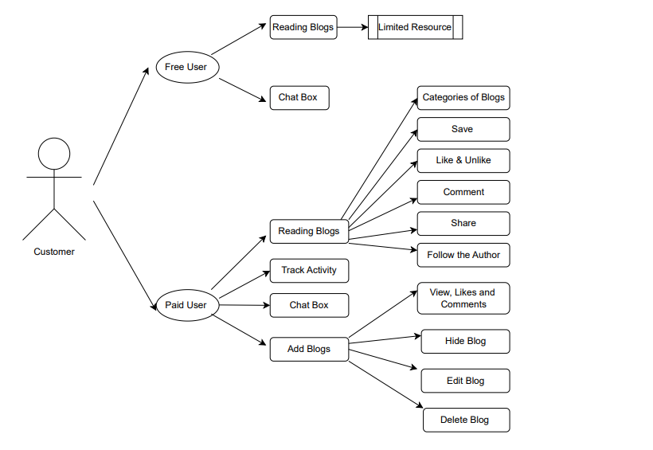

**3.1.2 Blogger WorkFlow**

**3.1.2 User Case for Blogger**

**3.1.2.1 User Login Page**

* **Objective**: To authorize right customer with his login credentials
* **Features**: Sign in to access the functionalities.

**3.1.2.2 User Home Page**

* **Objective**: Access to all the services provided.
* **Features**: Customer can select a service which would redirect him to the cart page.

**3.1.2.3 Add a Blog**

* **Objective**: Access to all the services selected by the customer.
* **Features**: User can view all the services selected and can schedule the time by clicking on the service box.

.

**3.1.2.4 Categories**

* **Objective**: Redirects to all the Categories selected by user.
* **Features**:

User can choose a category

**3.1.2.5 Post Details Page**

* + Post Header:

- Title, post content, featured images, publish button, social share buttons, post category, and tags.

* + Post Content:

- Full content of the post with support for multimedia (images, videos, embeds).

- Inline ads and related CTAs.

* + Comments Section:

- Allow users to comment with moderation tools for administrators.

* + Subscription/Monetization CTA:

- Banner or button for subscribing to premium content or joining as a member.

* + Related Content:

- Display similar posts at the bottom to encourage further engagement.

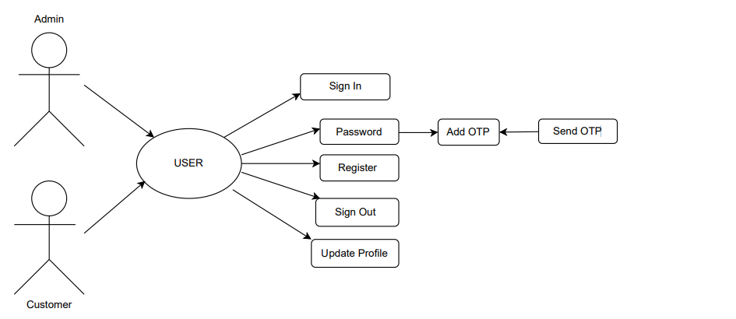

**3.1.3 Flow of user and admin**

* 1. **Non-Functional Requirements**

**3.2.1 Interface**

User interfaces must be intuitive and user-friendly.

**3.2.2 Constraints and Performance**

* Number of Concurrent Users: The system should handle at least 1000 transactions/inquiries per second.
* System Resilience: The application should be resilient to temporary server failure.

**3.2.3 Hardware and Software Requirements**

**Hardware-** Intel Core i5 or higher (or AMD equivalent), 8 GB RAM, 512 GB SSD or larger.

**Software-**

**Operating Systems**: MS Windows 13, Ubuntu 22.04.

**Database**: MySQL.

**Server**: Embedded Tomcat.

**Browsers**: Compatible with modern web browsers.

**3.2.4 System Design**

**Front-End:** Developed using React.js.

**Back-End:** Built with Spring Boot for server-side logic.

**Database:** MySQL for storing user data, orders, and other system information.

**Server:** Embedded Tomcat for hosting the application.

1. **Project Design**

**4.1 Data Model**

**4.1.1 Database Design**

Table 1: Users

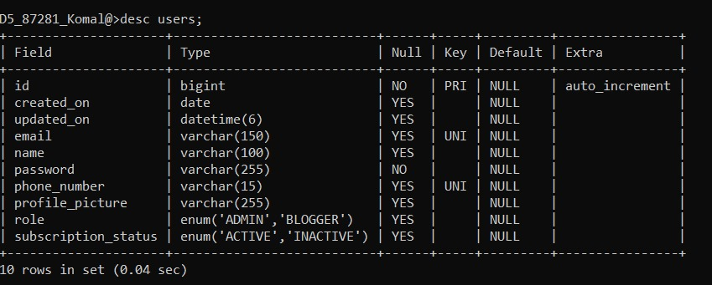

Table 2 :Categories

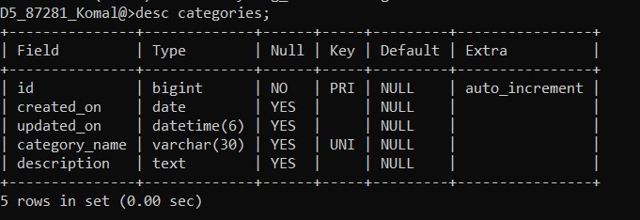

Table 3 : Analytics :

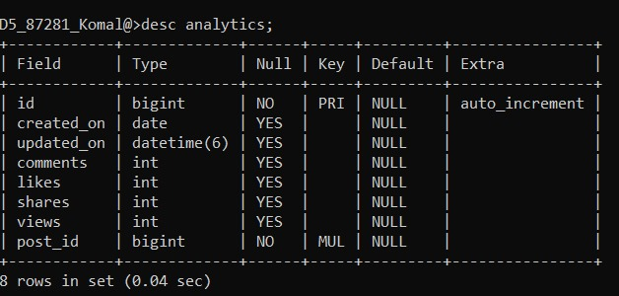

Table 4 : Ads

Table 5 : Comments

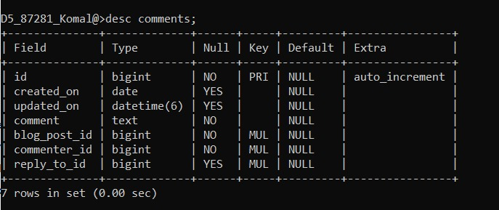

Table 6: Tags

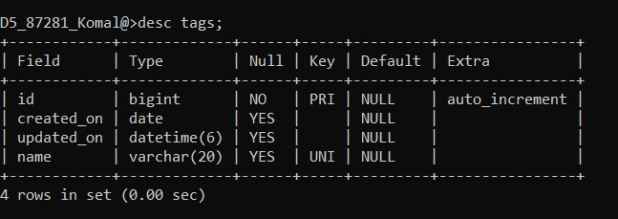

Table 7: Posts

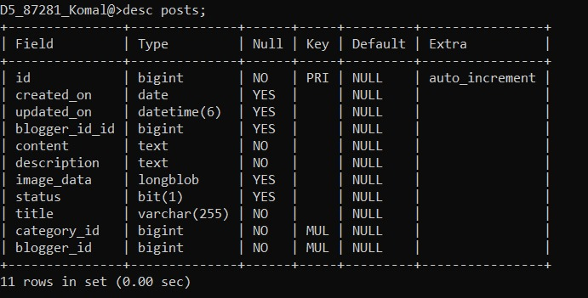

**4.2 Process Model**

**4.2.1 ER Diagram**

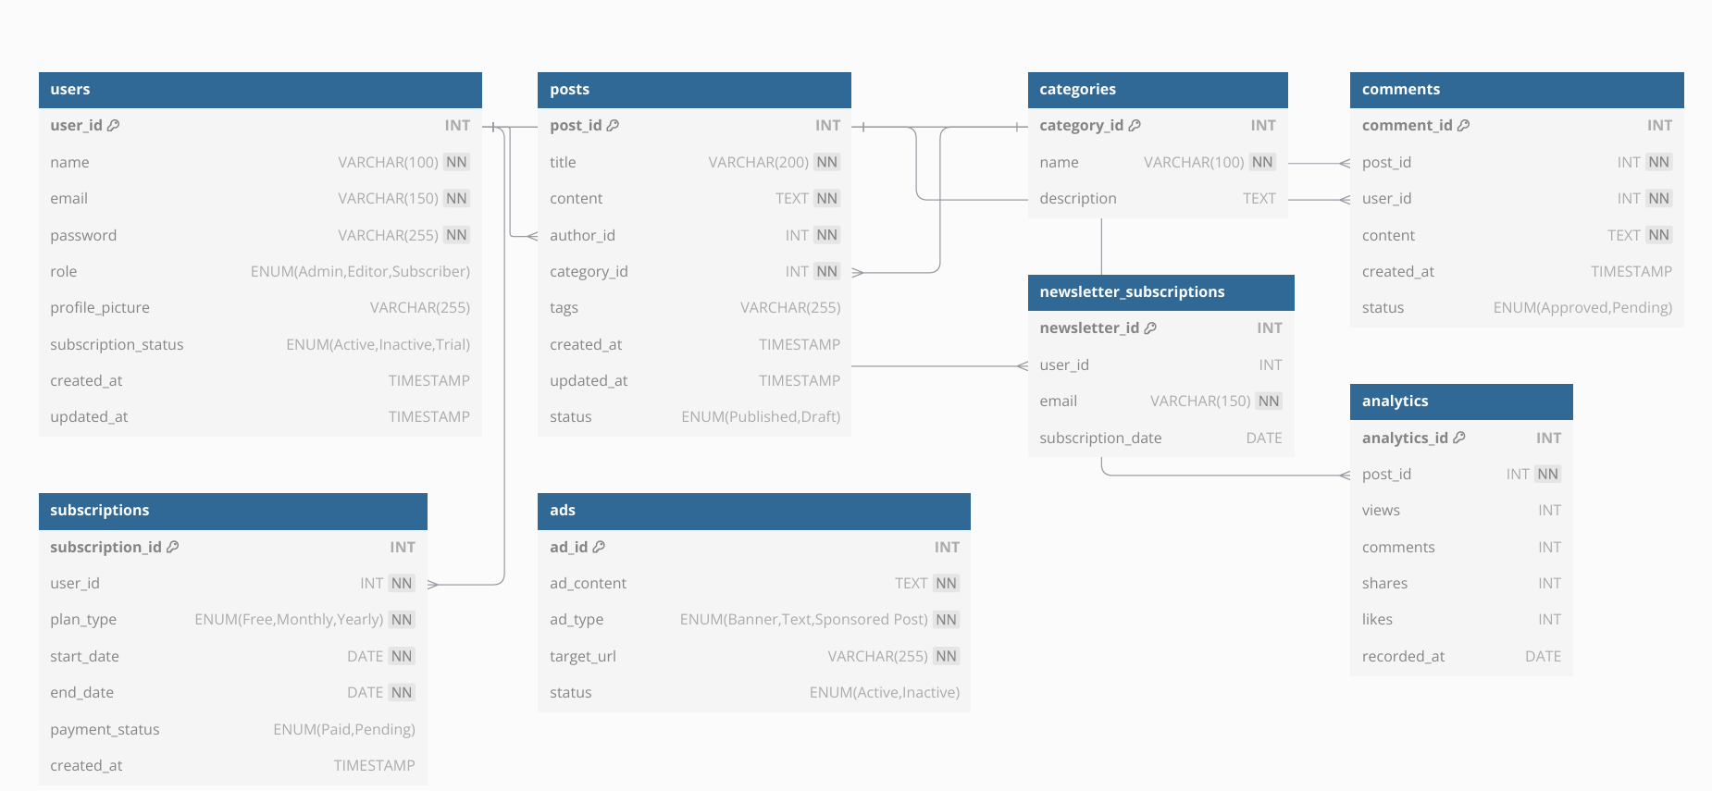

**5.Project Screenshots**

Home Page

Url - <http://localhost:3000/>

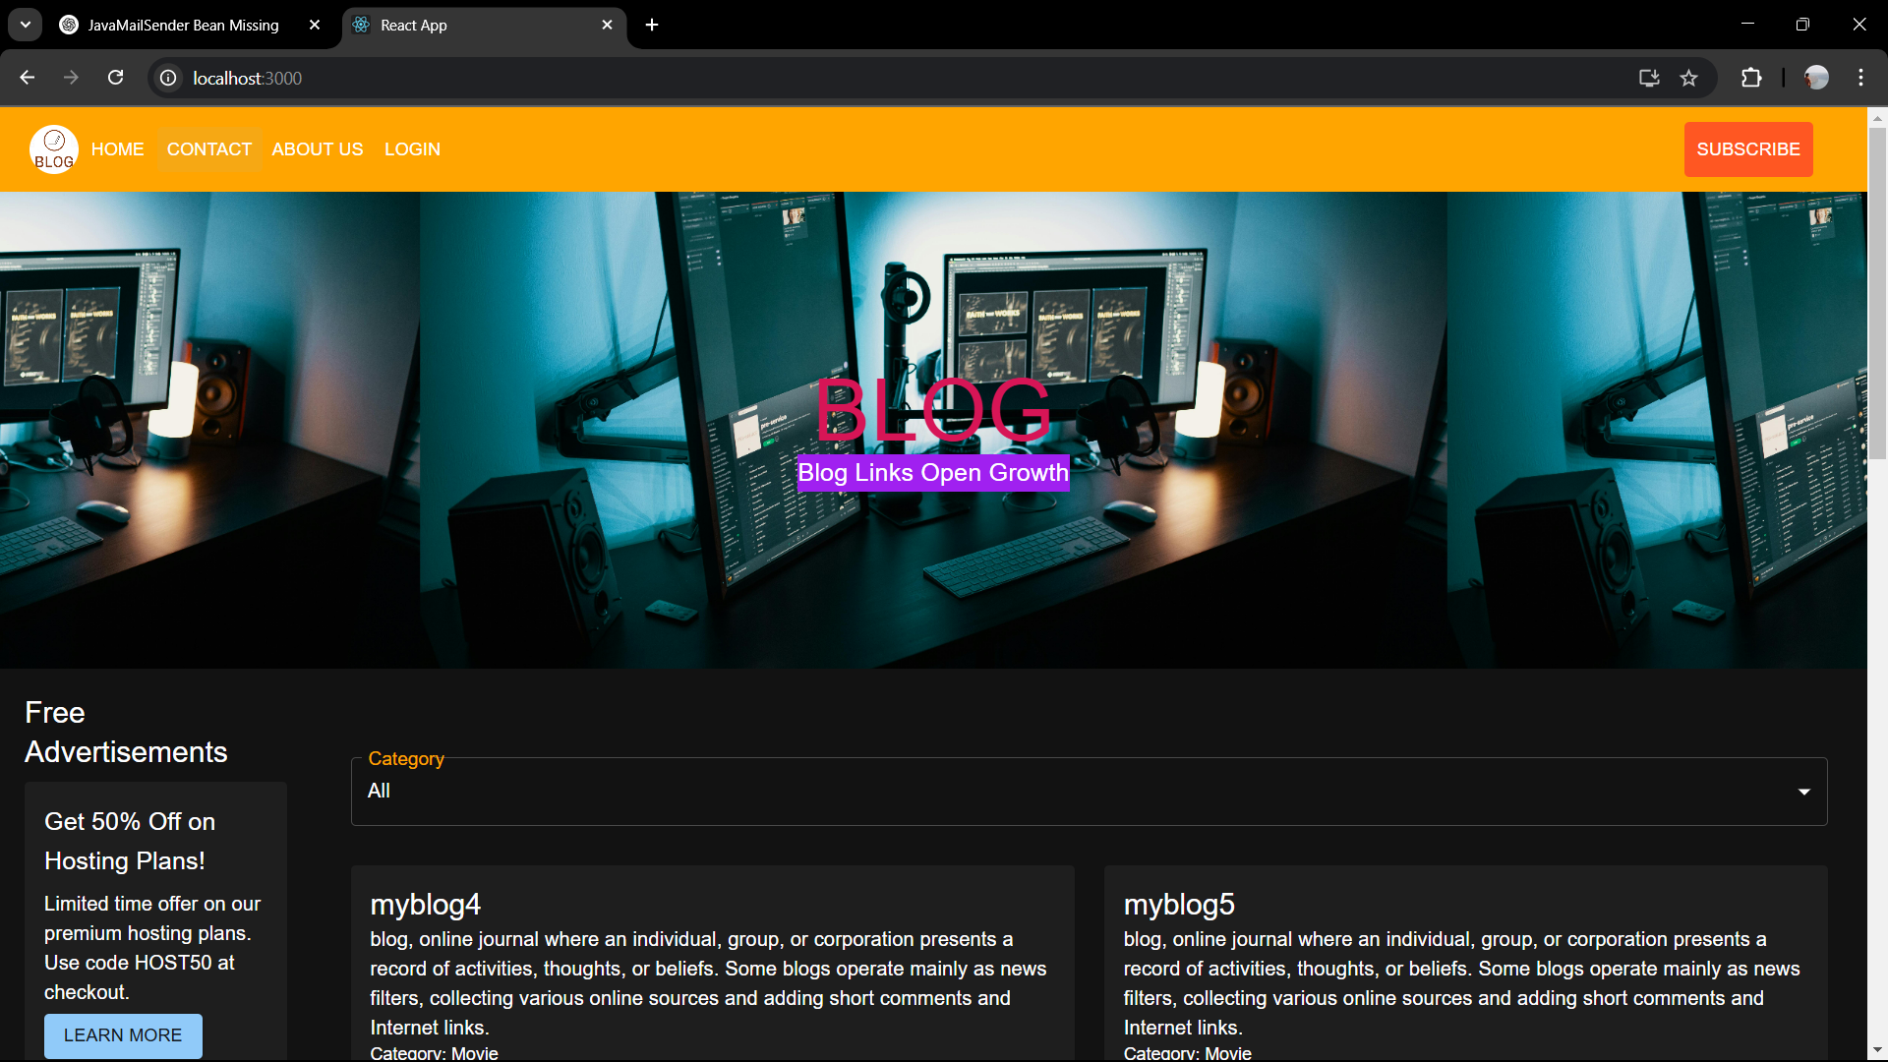

Url - http://localhost:3000/login

Url- <http://localhost:3000/register>

Added Post UI :

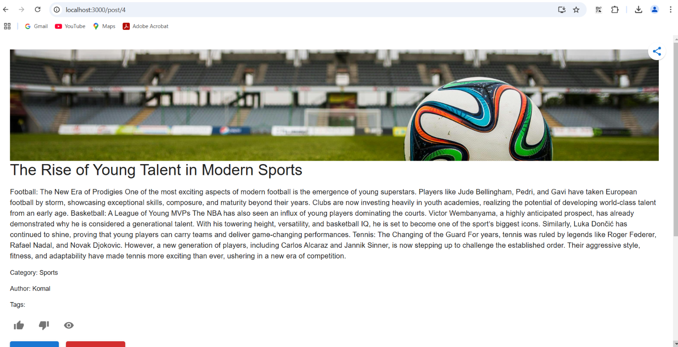

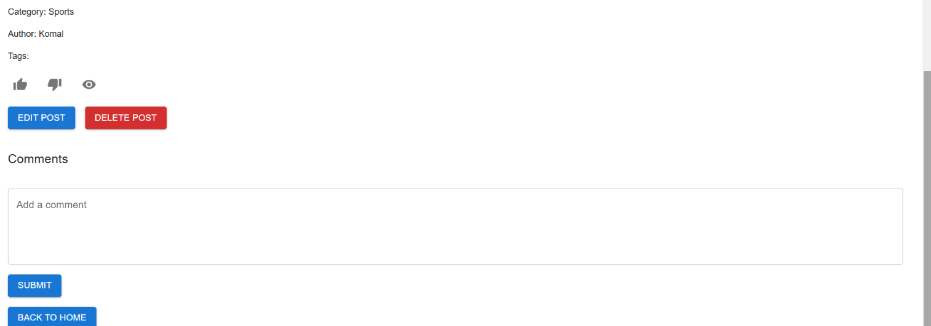

Bloggers Post :



**Admin Page**

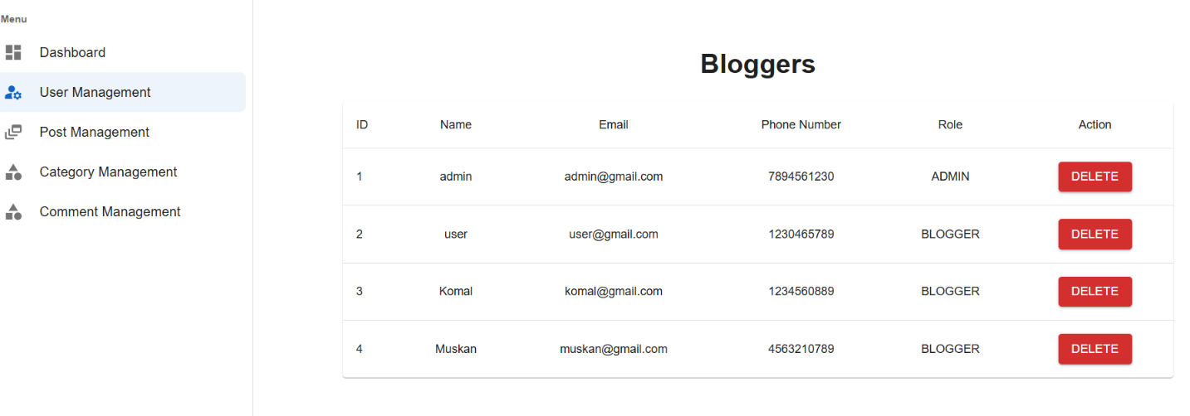

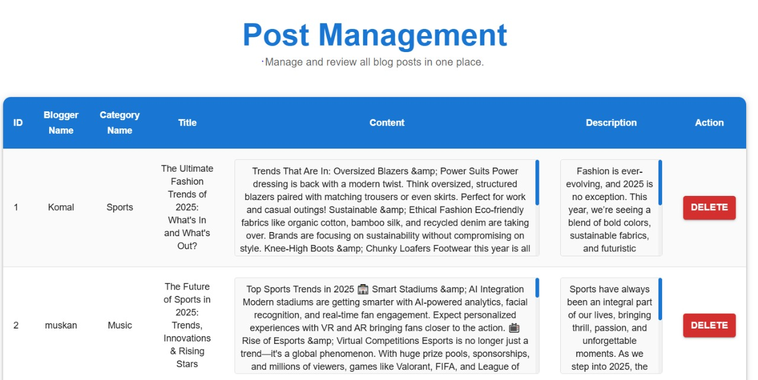

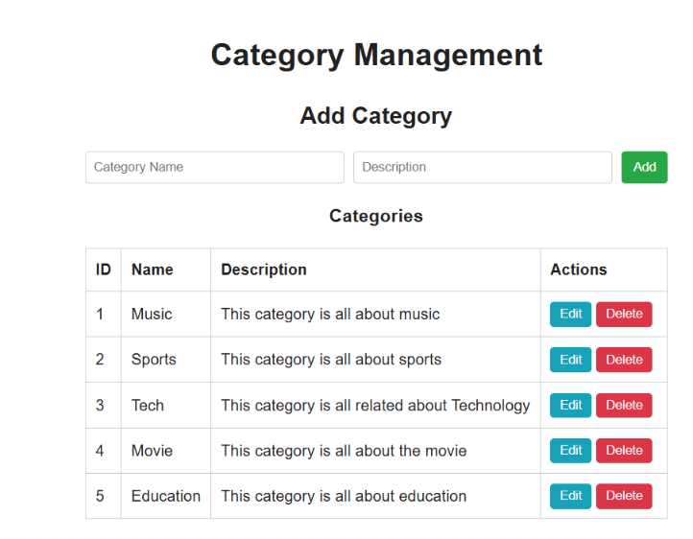

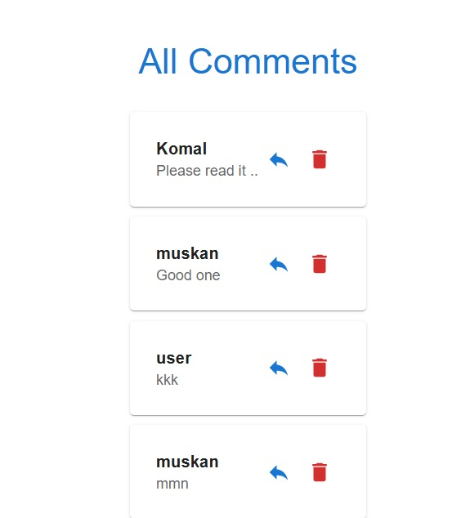

**6.CONCLUSION**

The Online Blog Management System provides a robust, secure, and user-friendly platform for administrators, authors, and readers to interact seamlessly. With advanced authentication mechanisms, efficient performance, and high reliability, this system ensures a smooth blogging experience. Its scalability and portability allow for future enhancements, making it an ideal solution for modern content management.

**7. REFERENCES**

1. Spring Boot Documentation URL: https://spring.io/projects/spring-boot

2. React.js Documentation URL: <https://reactjs.org/docs/getting-started.html>

3. Redux Documentation URL: <https://redux.js.org>

4. Java Programming Language URL: <https://www.oracle.com/java/>

5. MySQL Workbench Documentation URL: <https://dev.mysql.com/doc/workbench/en/>

6. Spring Boot with React and Redux URL: <https://www.baeldung.com/spring-> boot-react-and-redux

7. Java Persistence API (JPA) Documentation URL: <https://www.eclipse.org/eclipselink/documentation/2.7/>

8. Swagger Documentation for Spring Boot URL: <https://springdoc.org/>

9. MDN Web Docs URL: <https://developer.mozilla.org/>

10. React Redux Integration Guide URL: https://react-redux.js.org